Assignment 2
Due: After Unit 5
Total: 100 marks
Weight: 15% of your final grade
Answer all questions in this assignment. Submit your completed work to your Academic Expert for marking and feedback using this Assignment Drop Box.
- (12 marks) Answer the following questions (150 words max/question).
- Using an example, explain how referential integrity is established during the creation of database tables?
Referential integrity is especially important to implement at the creation of database tables. Referential integrity constraints will ensure that all new data inserted into the data must validate the foreign key constraint rule. Newly inserted data must have valid referential data to point to. It is much easier to enforce RI at the onset of a table, whereas implementation after data exists may involve cleaning or correcting of existing data.
- Explain the factors that need to be considered for creating an index on a specific table column.
Indexing, when properly used, can be an extremely impactful way to improve the performance of database interactions. Indexes provide the dabase query with information on how data should be sorted, so quick scanning and retrieval can be achieved. The more records that exist within a table, the slower it takes for a database to find desired records. Indexes can speed this process up by indicating which fields are typically used to locate records. Improperly used indexing can also cause the opposite, and slow the performance of a database. When too many indexes exist, they negate the performance gain, as the database engine must search each of the indexes until the criteria is matched. In addition, indexes can consume great deals of storage space, which can impose financial costs as well. Analysis of how a table will be used must be considered when determining which tables to index and how.
- Discuss the difference between triggers and stored procedures.
Triggers are stored procedures are both compiled executable blocks of code that can any type or number of SQL commands. Both support receiving objects as parameters. Triggers are linked with any DML or DDL operation, be it a table or data creation, modification or update, even user logons can initiate trigger operation. Depending on the type of trigger, different parameters are available in the context of execution. This can allow for validation or manipulation of the data of the trigger before, during or after execution, and even cancellation of the triggering event. Stored procedures, however are executed programmatically and support both input and output parameters. Stored procedures may alter or commit data to database tables, or simply perform calculations and return values. The usage and attitudes towards triggers and stored procedures has changed greatly over time, especially depending on database technology, and both have pros and cons. Triggers can provide clean and easy maintenance of data related operations, but are not immediately obvious to a casual observer, if not documented properly they can be easily forgotten or neglected. Enforcement of business and domain operation used to be encouraged to be maintained with in the database, allowing for easy porting to different interfaces, however more recently the practice of removing all but basic storage operations is become the trend.
- (40 marks) Consider these three relations and then write SQL statements to answer the questions that follow.
TRAVEL_AGENT (TA_no, name, age, salary)
CUSTOMER (C_ID, name, departure_city, destination, journey_class)
TRANSACTION (number, C_ID, TA_no, date, amount_paid)
- Compute the number of different customers who have a transaction.
Select count (c_id) from customer
- Display the name of the oldest travel agent.
Select top 1 name from CUSTOMER order by age desc;
- List the total number of transactions for each travel agent. Consider only those transactions where the amount paid exceeds 1000.
Select count(tx.number), ta.name from transaction tx inner join travel_agent ta on ta.ta_no = tx.ta_no where tx.amount_paid > 1000 group by ta.name
- Display the names and ages of the travel agents who have arranged journeys for customer “John Smith”, in descending order of age. (Use a subquery.)
Select ta.name, ta.age from travel_agent ta where ta.ta_no in
( select tx.ta_no from transaction tx inner join customer cust on cust.c_id = tx.c_id where cust.name = ‘John Smith’)
Order by ta.age desc
- Display the names and ages of travel agents who have arranged journeys for customer “John Smith”, in descending order of age. (Do not use a subquery.)
Select ta.name, ta.age from travel_agent ta inner join transaction tx on tx.ta_no = ta.ta_no inner join customer cust on cust.c_id = tx.c_id where cust.name = ‘John Smith’ order by ta.age desc
- Display the age of travel agents who have arranged journeys for customer “John Smith” to “Ottawa”. (Use a subquery.)
Select ta.age from travel_agent ta
inner join transaction tx on tx.ta_no = ta.ta_no
inner join customer cust on cust.c_id = tx.c_id
where customer.c_id in ( select c_id from customer where destination = ‘Ottawa’ and name = ‘John Smith’)
- Display the age of travel agents who have arranged journeys for customer “John Smith” to “Ottawa”. (Do not use a subquery.)
Select ta.age from travel_agent ta
inner join transaction tx on ta.ta_no = tx.ta_no
inner join customer cust on cust.c_id = ta.c_id
where cust.destination = ‘Ottawa’ and cust.name = ‘John Smith’
- Display the names and salaries of all travel agents who have not arranged journeys for customer “John Smith”, in ascending order of salary.
Select ta.name, ta.salary from travel_agent ta where ta.ta_no not in
( select distinct ta_no from transaction tx inner join customer cust on cust.c_id tx.c_id where cust.name = ‘John Smith’)
- Display the names of travel agents who have five or more transactions.
Select ta.name from travel_agent ta
inner join transaction tx on tx.ta_no = ta.ta_no
group by ta.ta_no, ta.name
having count(tx.number) >= 5
- Display the names of all travel agents who have arranged at least ten journeys to “Ottawa”.
Select ta.name from travel_agent ta
inner join transaction tx on tx.ta_no = ta.ta_no
inner join customer cust on cust.cust_id = tx.cust_id
where cust.destination = ‘Ottawa’
group by ta.ta_no, ta.name
having count(tx.number) >= 10
- (8 marks) Consider the following Realtor database with three relations. Write SQL statements for creating a view called AgentsOfTheYear that will display the name and address of realtors who have sold a total amount of 5 million dollars’ worth of properties in 2021.
RealtorAgent (realtor_no, name, age, address, commission_percentage)
Customer (C_ID, name, property_id, property_address, description, property_tax, property_value)
Transaction (realtor_no, C_ID, property_id, price_sold, date_sold)
Create or replace view AgentsOfTheYear as
SELECT ra.name, ra.address
from RealtorAgent ra
inner join transaction tx on tx.realtor_no = ra.realtor_no
where extract(year from date_sold) = 2021
group by tx.realtor_no, ra.name, ra.address
having sum(tx.price_sold) > 5000000
- (10 marks) Consider the following relations:
Student (student_no, name, address, GPA)
Course (course_no, title, texbook)
Instructor (instructor_no, name, phone_no, specialization)
Registration (student_no, course_no, instructor_no, session)
Qualified_to_teach (instructor_no, course_no)
- Determine the relationships among these relations. List the primary keys for each relation and any foreign keys necessary to establish the relationships and maintain referential integrity.
- Student:
  - Primary key: student_no
  - Foreign keys: none
  - Relationships:
    - Student (one) to (many) Registrations
- Course:
  - Primary Key: Course_no
  - Foreign Keys: None
  - Relationships:
    - Course (one) to (many) Qualified_to_teach
    - Course (one) to (many) Registration
- Instructor:
  - Primary Key: instructor_no
  - Foregin Keys: none
  - Relationships:
    - Instructor (one) to (many) Registration
    - Instructor (one) to (many) Qualified_to_teach
- Registration:
  - Primary Key:student_no, course_no, instructor_no, session
  - Foreign Key:
    - student_no -> student.student_no
    - course_no -> course.course_no
    - instructor_no -> instructor.instructor_no
  - Relationships:
    - Registration (many) to (one) Student
    - Registration (many) to (one) Course
    - Registration (many) to (one) Instructor
- Qualified_to_teach:
  - Primary Key: Instructor_no, course_no (composite)
  - Foreign Keys:
    - instructor_no -> Instructor.instructor_no
    - course_no -> Course.course_no
  - Relationships:
    - Qualified_to_teach (many) to (one) Instructor
    - Qualified_to_teach (many) to (one) Course

- Write SQL query to list the names of instructors who have taught COMP 378 but not COMP 418 during the following sessions: Winter 2020 and Winter 2021.
Select ins.name from Instructor ins
Inner join registration c378Reg on c378Reg.instructor_no = ins.instructor_no
inner join course c378 on c378.course_no = c378Reg.course_no
where c378.title = ‘COMP 378’ and ( c378Reg.session = ‘Winter 2020’ or c378Reg.session = ‘Winter 2021’ )
and NOT EXISTS
(
select 1 from Registration regEx
inner join Course cEx on cEx.course_no = regEx.course_no
where regEx.instructor_no = ins.instructor_no AND
cEx.title = ‘COMP 418’ and ( regEx.session = ‘Winter 2020’ or regEx.session = ‘Winter 2021’ )
)
- (16 marks) Answer the following questions (250 words max/question).
- Discuss the distribution of application logic components across clients and servers in the client/server environment.
- Application logic components are one part of three that make up a three tier application architecture. A three tier application is comprised of presentation layer, application logic layer, then storage layer. The presentation layer is what the user sees and interacts with. The application logic layer is the main intelligence of a system. Its where data is manipulated, decision making, or validations are enforced. The behaviours and activities of the application is maintained here. The storage layer is responsible for storing and retrieval of the data.
- What are the most important security features for data management software?
- The most important security features of a data management software includes limiting access to schemas or viewing of data, enforcement of database objects, integrity constraints, checks of a relational database system, authorization rules to ensure users may only permit their assigned actions, ensuring user defined functions, constraints and objects are executed or triggered properly, encryption and data protection is used, authentication to ensure the user attempting to access the resource is properly identified and backing up and journaling of data.
- What threats to data security must be addressed in a comprehensive data security plan?
- Threats to data security include: accidental loss due to hardware, software failure or human error; theft or fraud where people perpetrate activities to steal or alter data; loss of privacy or confidentiality, where protected or private information is accessed or distributed without permission; and loss of availability, where the
- What is the difference between shared locks and exclusive locks?
- (6 marks) Consider the concurrent execution of the following transactions. List two problems that may occur from the concurrent execution of these two transactions.
T1 | T2
Read A | Read B
Read B | Write A
Write C | Read C
Write A | Write B
Commit | Commit
- (8 marks) Consider the two application environments represented in Figure 1 and Figure 2. Identify the various security considerations that are relevant to each environment.
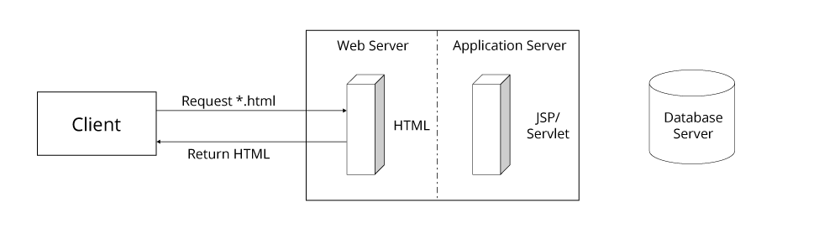
Figure 1: Static page request
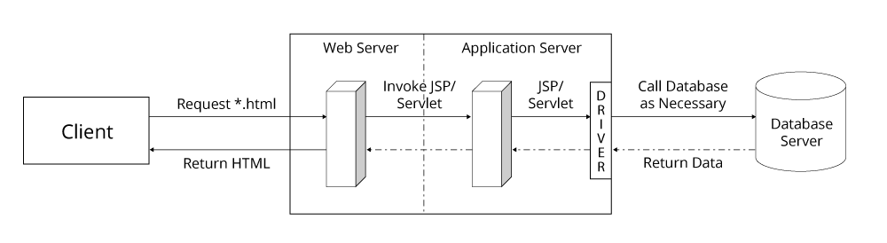
Figure 2: Dynamic page request

